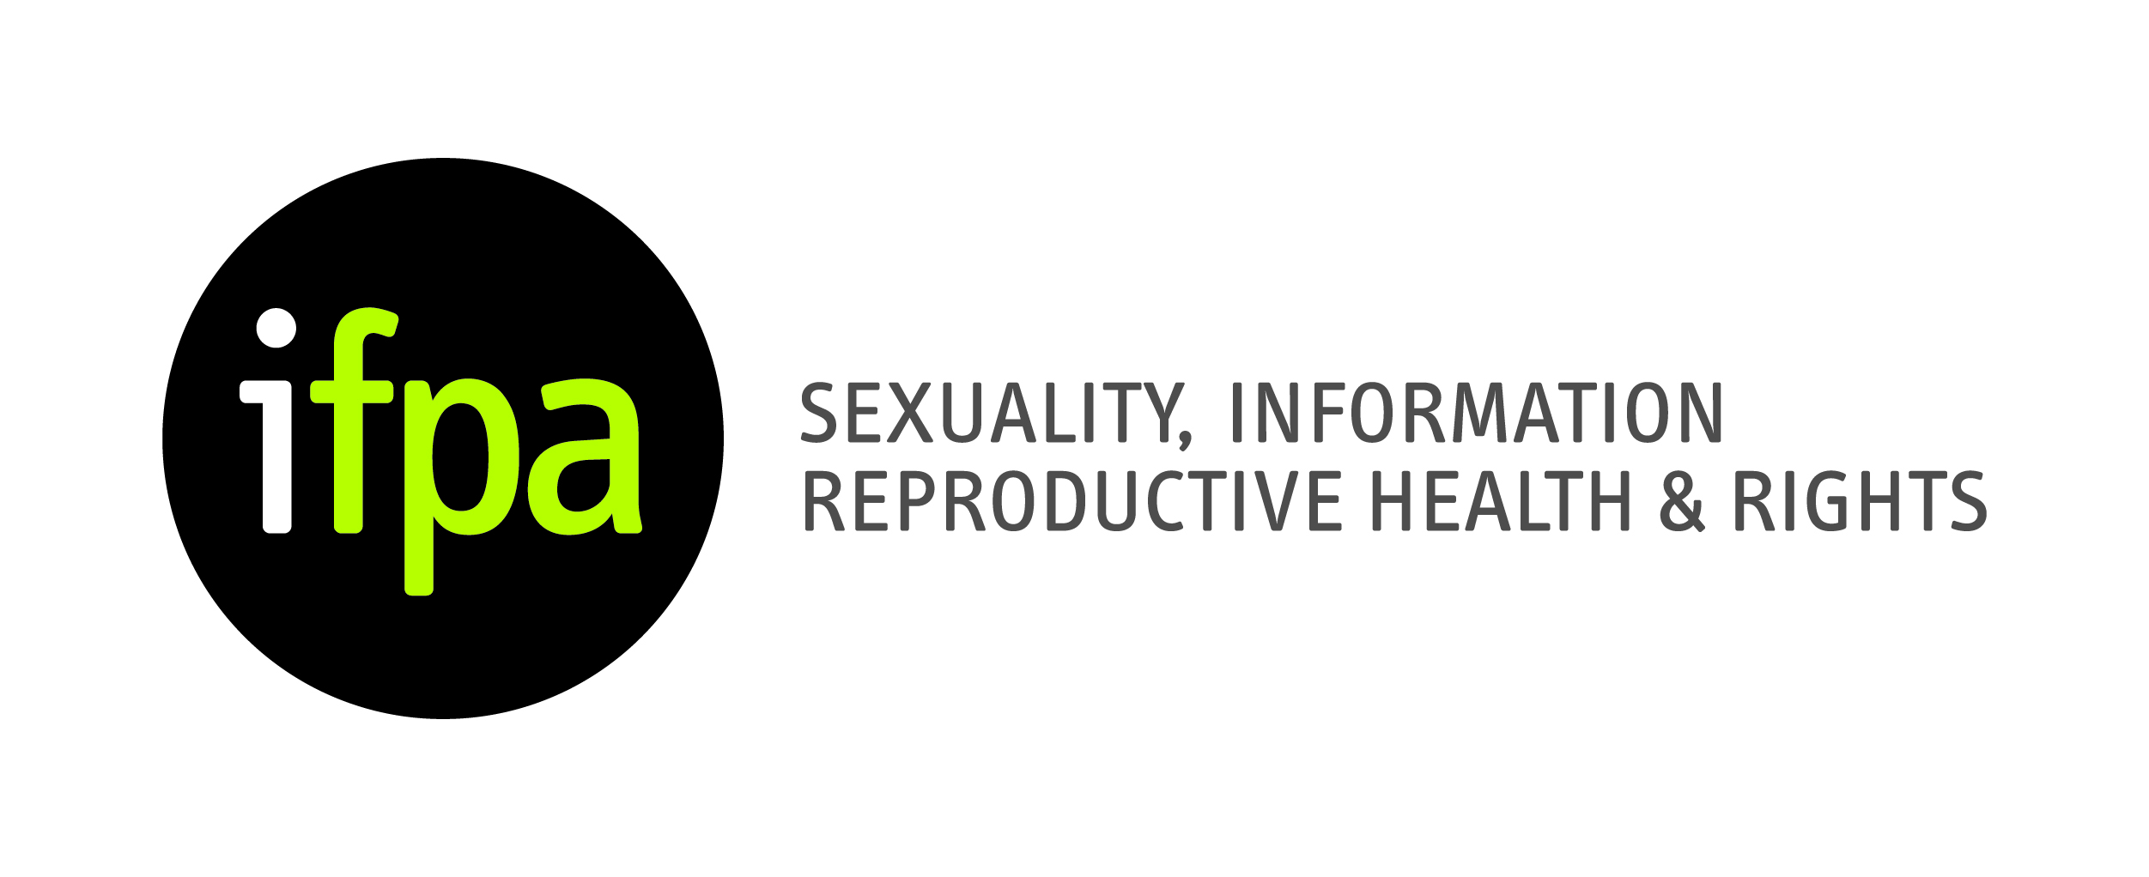

Irish Family Planning Association (IFPA)

Sexual Health Training

Date: Thursday 17th September 2015
Time: 9am – 5.30pm

Name: _________________________________________________

Address: _________________________________________________

_________________________________________________

Email: _________________________________________________
Please tick this box if you do NOT wish to receive the IFPA newsletter
Telephone: ___________________________________________________
Area of Expertise: _______________________________________________

Special Learning Requirement: ______________________________________

Have you attended an IFPA training programme before? Yes No

If so, please provide details of the course: _____________________________

How did you hear about this course?

IFPA website IFPA social media (Facebook, Twitter) Other

I ENCLOSE A FEE OF €120

Signature: ____________________________________________________

Date: __________________________

Payment required three weeks in advance of course.

Please return the completed application form, along with a cheque, bank draft or postal order made payable to the Irish Family Planning Association (IFPA), to:
Irish Family Planning Association, Solomons House, 42a Pearse Street, Dublin 2.

If you wish to pay by credit card, please send your application form along with your credit card details by fax to (01) 607 4486 or by email to anita@ifpa.ie.

