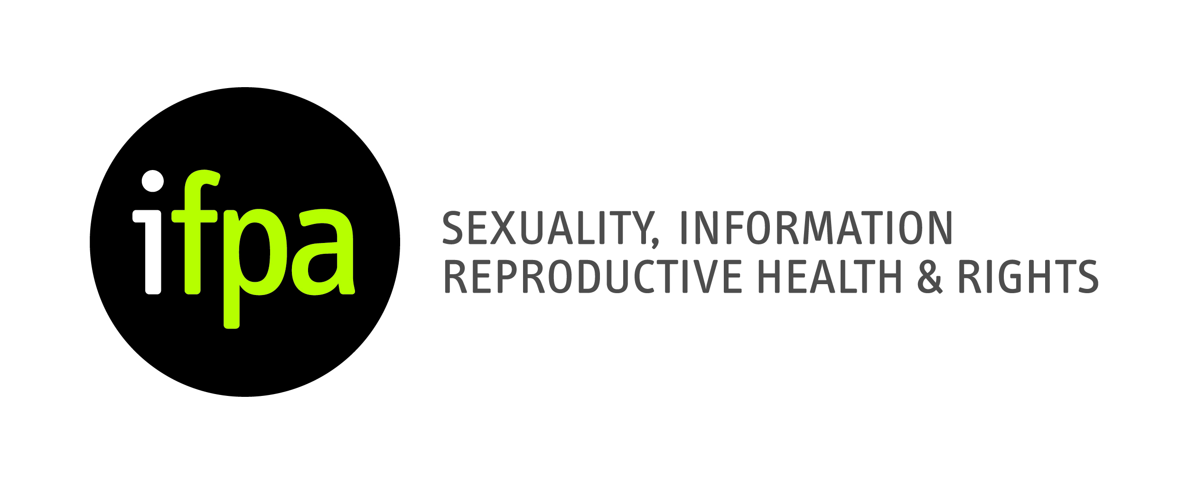

Irish Family Planning Association

Sexual Health Training

Name: _________________________________________________

Address: _________________________________________________

_________________________________________________

E-Mail: _________________________________________________
Please Check this box if you do NOT want to receive the IFPA’s eNewsletter
Telephone: _________________________________________________
Area of Expertise: _______________________________________________

Special Learning Requirement: ________________________________________

Have you attended an IFPA Training course before?

If so please detail: _______________________________________________

Please outline any special dietary requirements:
_____________________________________________ (Vegetarian, Vegan etc)

I ENCLOSE FEE OF €80

Signature: ____________________________________________________

Payment required three weeks in advance of course.

Return the completed application form along with a cheque, bank draft or postal order (payable to the IFPA) to IFPA, Solomons House, 42a Pearse Street, Dublin 2..

Cheques can be made payable to The Irish Family Planning Association
If you wish to pay by credit card, please send your application form along with your credit card details by fax to 01 607 4456 or anita@ifpa.ie

