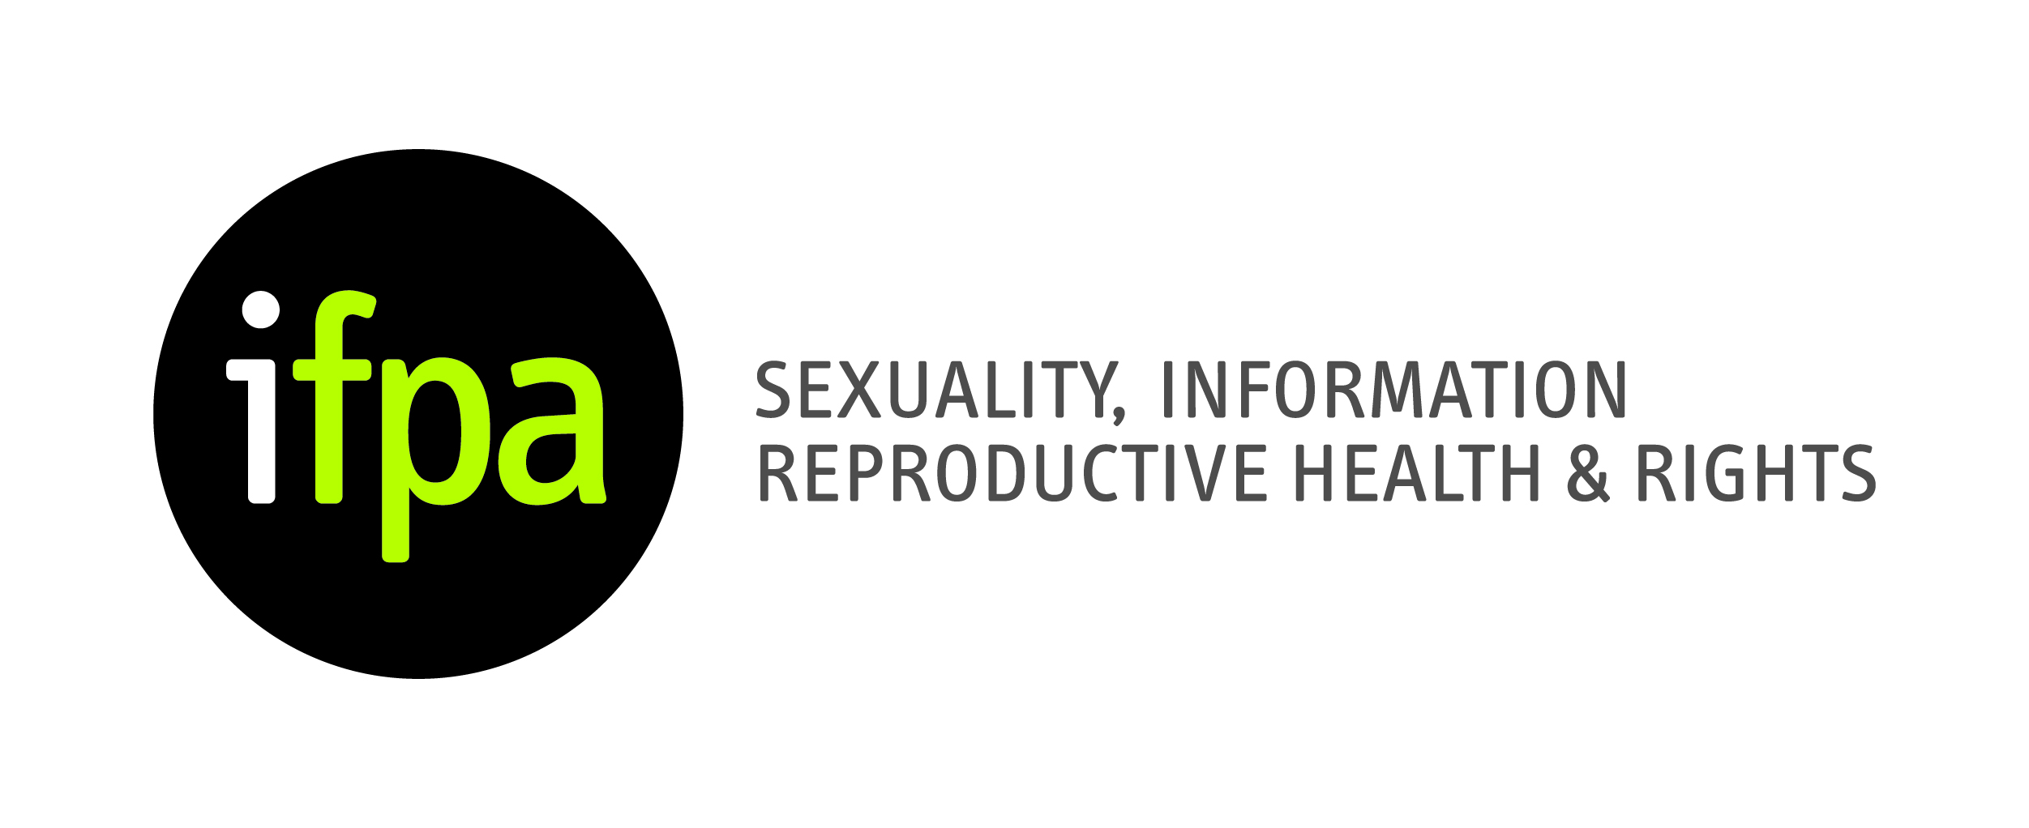
IFPA Project Officer – Part Time

Job Purpose
The IFPA Project Officer will support IFPA projects and the development of IFPA policy on sexual and reproductive health.

Key Objectives
- Carry out research in relation to sexual and reproductive health and rights in Ireland and internationally.
- Promote, monitor and evaluate the implementation of key IFPA projects.
- Prepare submissions, reports and briefing papers to funders and policy influencers. Work as part of IFPA team to ensure programmes, campaigns, projects and services are informed by best practice policy and research.

Main Tasks
Responsibilities
- Research, analyse and write policy briefing papers for diverse audiences.
- Produce articles, reports, submissions and best practice guides suitable for publication.
- Liaise with governmental and non-governmental agencies, and other stakeholders.
- Organise conferences, seminars and public events in support of IFPA strategic aims.
- Support the implementation of multiple long and short-term IFPA projects.
- Provide comprehensive and regular reports to donors and funders on progress of IFPA projects.

Person Specification Requirements
- A university degree in social sciences, humanities, health, education or other relevant fields.
- A track record and/or understanding of the development and delivery of reproductive and sexual health programmes.
- Knowledge, understanding and commitment to reproductive and sexual health rights within Ireland.
- Excellent spoken and written English.
- Ability to express clearly and concisely ideas and concepts in written and oral form; specific skills in report writing and briefings.
- Strong teamwork and interpersonal skills.
- Ability to take initiative and complete tasks in an autonomous manner.
- Ability to work to tight deadlines and manage a diverse range of tasks.

Contract Details
Two year contract subject to funding.
20 hours per week.
€12,000 to €14,000, depending on experience.

Applications
Applicants should send a curriculum vitae and application letter to Maeve Taylor, Senior Policy and Advocacy Officer (e-mail maeve@ifpa.ie; subject line: Project Officer), to be received by 5.00 p.m., Tuesday, 3rd June 2014.

